HOUSE PRICE INDEX PREDICTION USING
TIME SERIES DATA AND – MULTIVARIATE
LSTM

Pranav V Phutane
Manipal Institute of
Technology
Manipal,Karnataka
panu.phutane@gmail.com

Abstract—The House Price Index (HPI) is a measure that tracks changes in the prices of residential properties over time. It provides insights into real estate market trends, showing whether home prices are rising or falling. The index is typically calculated using repeat sales data or hedonic regression models, and is used by policymakers, economists, investors, and homebuyers to assess housing market health, inflation, and investment potential. Different countries and agencies, like the Federal Housing Finance Agency (FHFA) in the U.S., publish their own HPI based on regional data.

This is the first project I have made for my portfolio. At the start of this project i had no experience whatsover in building any ML project.

The project did serve as a stepping stone for many further, cutting edge projects I would go on to build. The model is an RNN-recurrent neural network and aims to predict hpi - house price index using time series data. The dataset was obtained from the Texas A&M Website and consisted of three columns - date, hpi , and numsold. The date column was used to create a time series model. The hpi column was the target variable and numsold is the number of houses in 1000s sold that year. I did go on to modify the dataset by adding more columns to create a multivariate lstm model as i believed that simply using the time series data would be too simple. the columns i went on to add and populate are – the corresponding year’s inflation rate, interest rate and gdp growth rate.

MY LEARNING

The project helped me understand time series data and taught me how to implement LSTM logic . I also did end up getting a pretty good accuracy in predicting the dependent variable . I did get a good understanding on how an ML project is supposed to be built which has helped me build more cutting edge projects since.

RESULTS

The image below shows the accuracy of the model created . While there is a major difference between actual and predicted values at the start, mostly due to unavailability of sufficient batch size data (each batch is 12 months and the discrepancy is for approximately the first 12 months of the dataset) , the model is able to understand and accurately predict values thereafter.
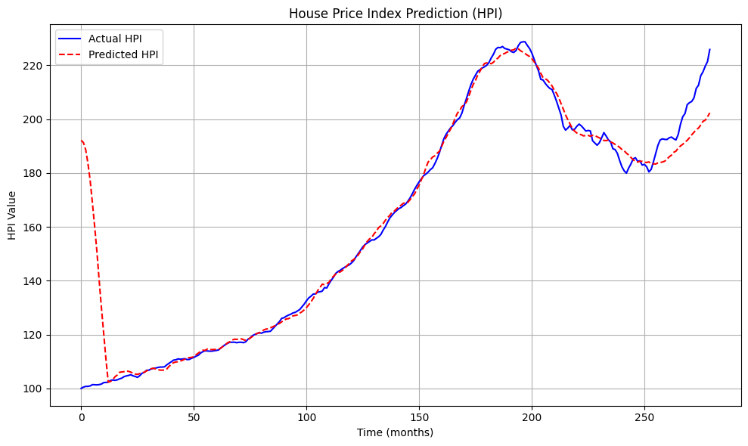

The project involves loading the dataset ‘enhanced-monthly housing.csv’
Into google colab which is followed by data visualization and
data preprocessing and cleaning to create a refined dataset for the
LSTM to work on. As for the LSTM itself, it is a multivariate
LSTM that uses time series data, interest rates, inflation rates and gdp
Growth rate to predict corresponding HPI

PROJECT RELEVANCE

Governments, real estate investors, and banks rely on accurate HPI forecasts for decisions on lending, investment, and policy-making. A multivariate LSTM can provide a data-driven, forward-looking estimate.

